2 Project Architecture
Perch supports ticket sales for temporary and mobile event businesses through a React interface, a Spring Boot application and a local H2 database (PostgreSQL in the production profile). The architecture separates HTTP handling, business rules and persistence. Organisers configure reusable seating layouts and publish events; customers reserve event seats, complete checkout and retrieve electronic tickets.
This class-diagram section describes main at source commit 48d55b49ecd9a7f21ba48b9c13d531469bb8cef4, inspected on 29 October 2026. Its two complementary views separate the persistent domain from the application services. They use the class compartments, visibility and numeric multiplicities taught in Lecture 3, pages 10–17. The separately required use case diagram is outside this section.

2.1 Class Diagram
Figure 2.1a shows the ten persistent domain classes. User represents customers, organisers, pending organisers and administrators through a UserRole value. OrganiserRequest and StudentVerificationRequest retain application outcomes; approved student eligibility is recorded on User rather than represented by a subclass. A user may organise multiple events, own venues and floor plans, and place bookings.
FloorPlan stores a reusable layout and its Seat records. Event optionally references a floor plan while in draft; publication requires a configured plan and creates EventSeat inventory. Each EventSeat stores its own price, availability and hold state. Seat and EventSeat have no direct object association. Event stores category, venueName and city as text but has no Venue object association. These display values do not introduce another persistent relationship.
A Booking belongs to one customer and one event. Its seatIds record the checkout selection; sold EventSeat objects link to the booking on confirmation. Each Ticket belongs to one booking and exactly one event seat, with a unique seat reference and ticket code. Optional multiplicities allow for unsold seats, draft events and pending or cancelled bookings. A confirmed purchase issues one ticket per sold seat.
Figure 2.1b shows the business classes. EventService manages events and floor plans; VenueService provides organiser-scoped venue reads; venue creation, editing and deletion are absent. UserService handles credentials and registration, while the two request services support administrator review. AdminService provides revenue and popularity statistics. Controllers invoke these services, which use Spring Data repository interfaces to persist the domain objects. DTOs carry response and request data across the HTTP boundary; the figures omit repetitive accessors, DTO classes and individual controller/repository classes.
SeatHoldService uses EventSeat versioning to detect competing holds, and ExpiredSeatHoldReleaseJob frees expired reservations. BookingService coordinates checkout with PaymentProvider, TicketService and BookingEmailService. MockPaymentProvider confirms locally; StripePaymentProvider creates a payment intent and confirmation follows a verified webhook. BookingRepository applies a write lock when looking up the payment reference. Ticket issuance shares the confirmation transaction. Email is best effort and requires mail configuration.

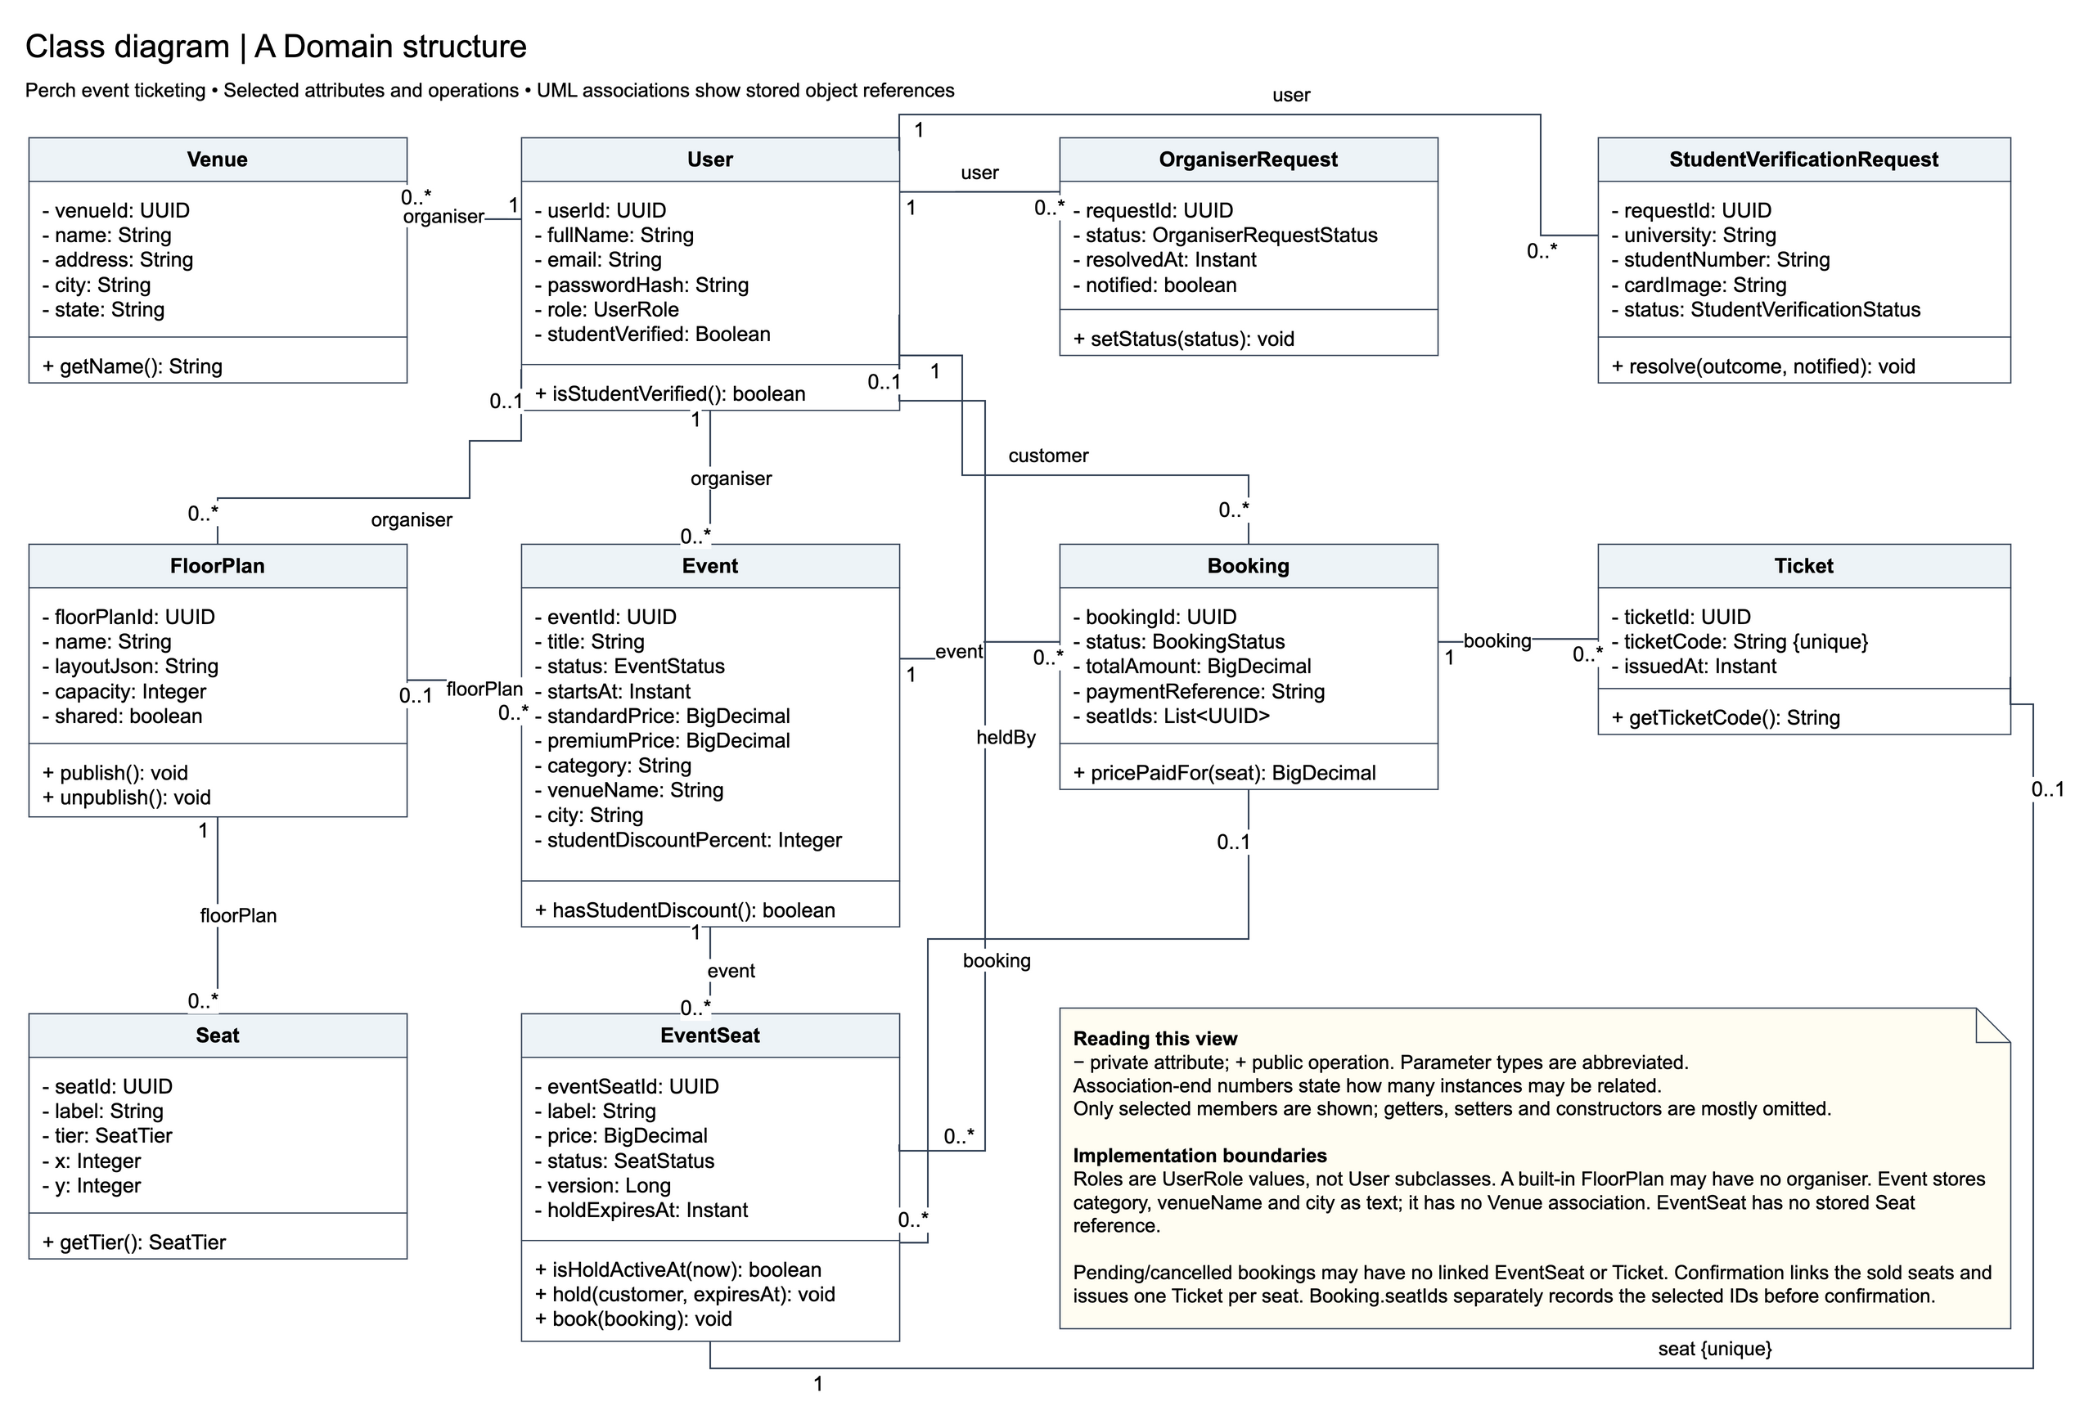
Figure 2.1a UML class diagram — domain structure. Selected members and association multiplicities reflect the inspected branch.

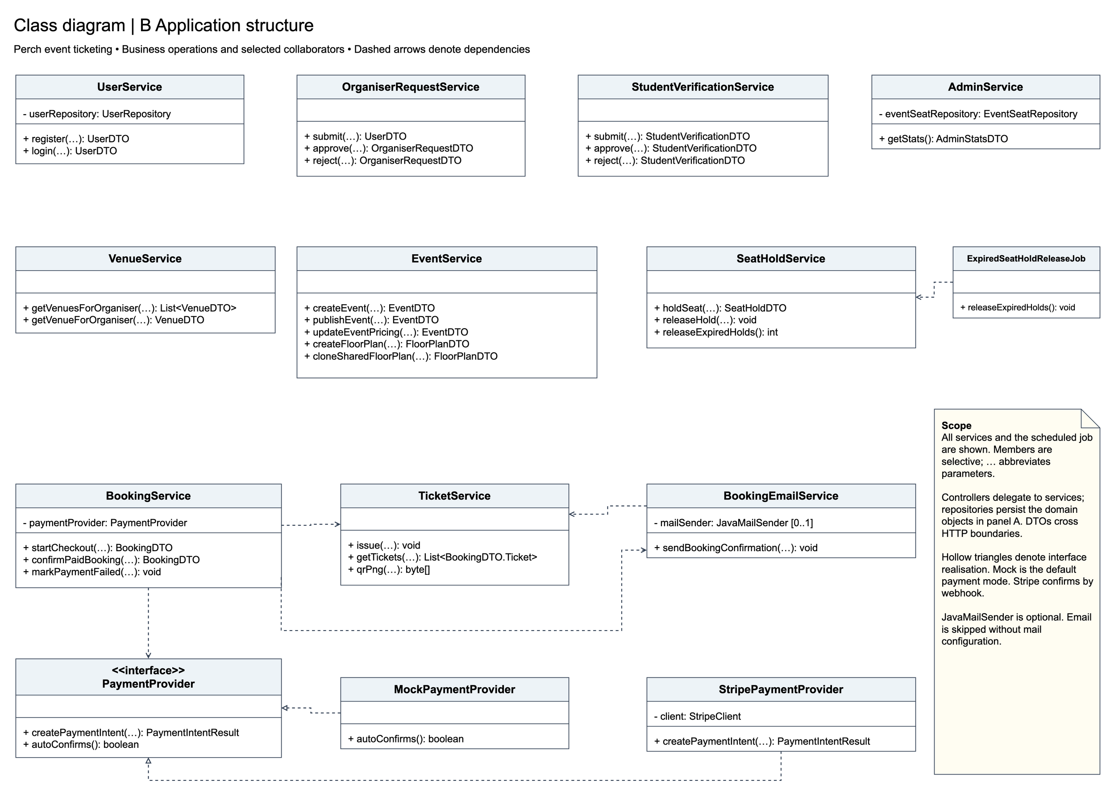
Figure 2.1b UML class diagram — application structure. Dashed open arrows denote dependencies; hollow triangles denote interface realisation.

